JNC Network / JS Communication
Integrated CRM Platform
Master Architecture & Implementation Plan
Lead management · WhatsApp/IndiaMART/Website lead capture · Inventory & suppliers
Order & shipment lifecycle · Electronic components inventory · RBAC · Reporting
Prepared: August 2026

Working Assumptions
The following assumptions shape the estimates and phasing in this document. Since exact team size, warehouse count and budget weren't specified, these are stated explicitly so they can be corrected before execution begins.
- Team size: 5–30 concurrent users (owner/boss, 2–4 admins, several sales/employee seats), growing to ~50 over 2 years.
- 1–3 warehouses/godowns to start, India-based, single currency (INR).
- WhatsApp via an official BSP (Interakt, WATI, Gupshup, AiSensy) rather than raw Meta Cloud API integration, for faster go-live.
- IndiaMART integration uses their Lead Manager (CRM) Push/Pull API — no scraping.
- Budget target: lean but professional — single-cloud-region deployment, not enterprise scale.

1. Executive Summary
This plan delivers a single system of record — JNC-CRM — that replaces spreadsheets and scattered WhatsApp threads with one pipeline: lead capture (from IndiaMART, Website, and WhatsApp) → qualification → follow-up → quotation → order → dispatch → delivery → repeat business, backed by a real inventory ledger for electronic components across warehouses and suppliers, and role-based dashboards that are visual and fast to scan on a factory-floor or sales-desk phone.
It is built in 5 phases over roughly 20 weeks by a small team (see Section 14), with unified lead capture and inventory basics prioritized early since they compound in value the sooner they're live.

2. System Architecture Overview
Pattern: modular monolith at launch (single deployable, cleanly separated service modules) → split into microservices later only if a specific module (e.g. inventory, automation) needs independent scaling. This avoids premature distributed-systems overhead for a 5–30 user system while keeping a clean seam to split later.
Key correction reflected below: WhatsApp is a lead-capture channel only. It is never used to auto-send delivery, dispatch, follow-up, or reminder messages — the Notification Dispatcher routes outbound alerts to Email, SMS, and in-app/push only. A new Supplier Company registry sits alongside the warehouse module so every inward stock movement is linked to the company you bought it from.
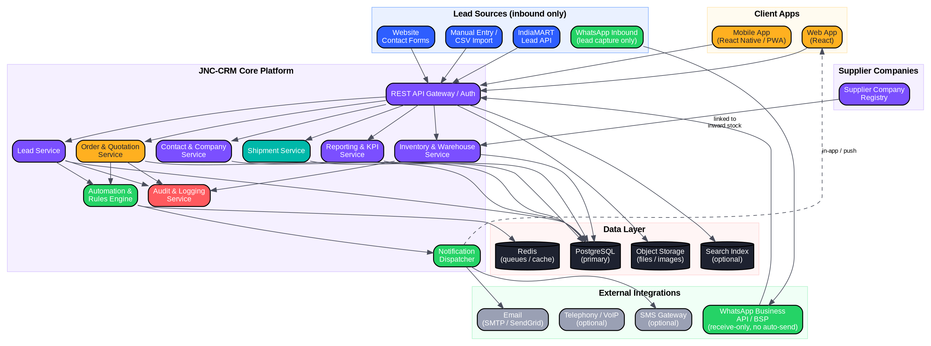
Figure 1 — End-to-end system architecture: WhatsApp/IndiaMART/Website as inbound-only lead sources, core services, outbound channels (Email/SMS/in-app — no WhatsApp), data layer, clients, and the Supplier Company registry.

3. Data Model

3.1 Entity-Relationship Diagram
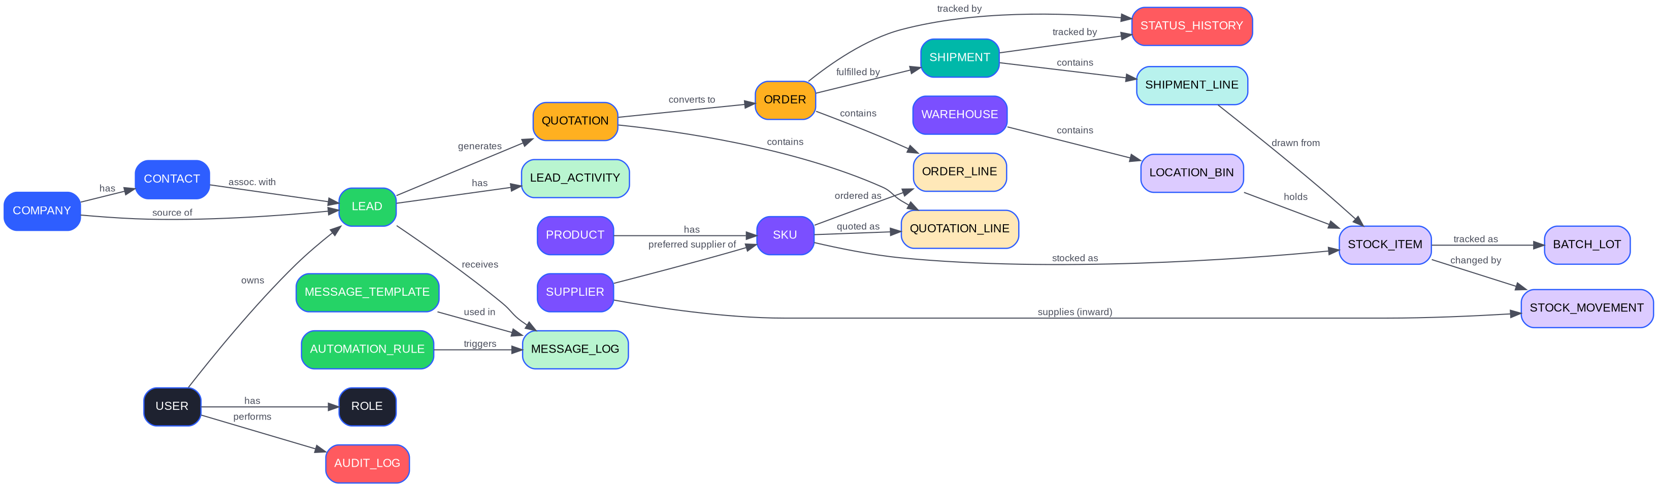
Figure 2 — Core entity relationships across leads, orders, inventory, shipments, RBAC, and the Supplier registry.

3.2 Key Entity Notes
- Batch/Lot tracking lives on STOCK_ITEM + BATCH_LOT so components with date codes or reels can be traced to the exact inward shipment — critical for electronic components where suppliers/date codes matter for warranty/RMA.
- SUPPLIER is a first-class entity: every inward STOCK_MOVEMENT carries a supplier_id, and each SKU can have a preferred supplier for fast reorder lookup. The warehouse dashboard shows a live count of active supplier companies (see Section 8).
- STATUS_HISTORY is a generic append-only table (entity_type, entity_id, from_status, to_status, changed_by, changed_at, note) reused by both ORDER and SHIPMENT — separate from the general AUDIT_LOG (logins, permission changes, record edits/deletes).
- Soft-delete everywhere: deleted_at nullable column on all core tables. Nothing is hard-deleted; sub-admins/employees never get physical delete rights (see RBAC).

4. Core Workflows (Sequence Flows)

4.1 Lead Capture (IndiaMART / Website / WhatsApp) → Qualification → Follow-up

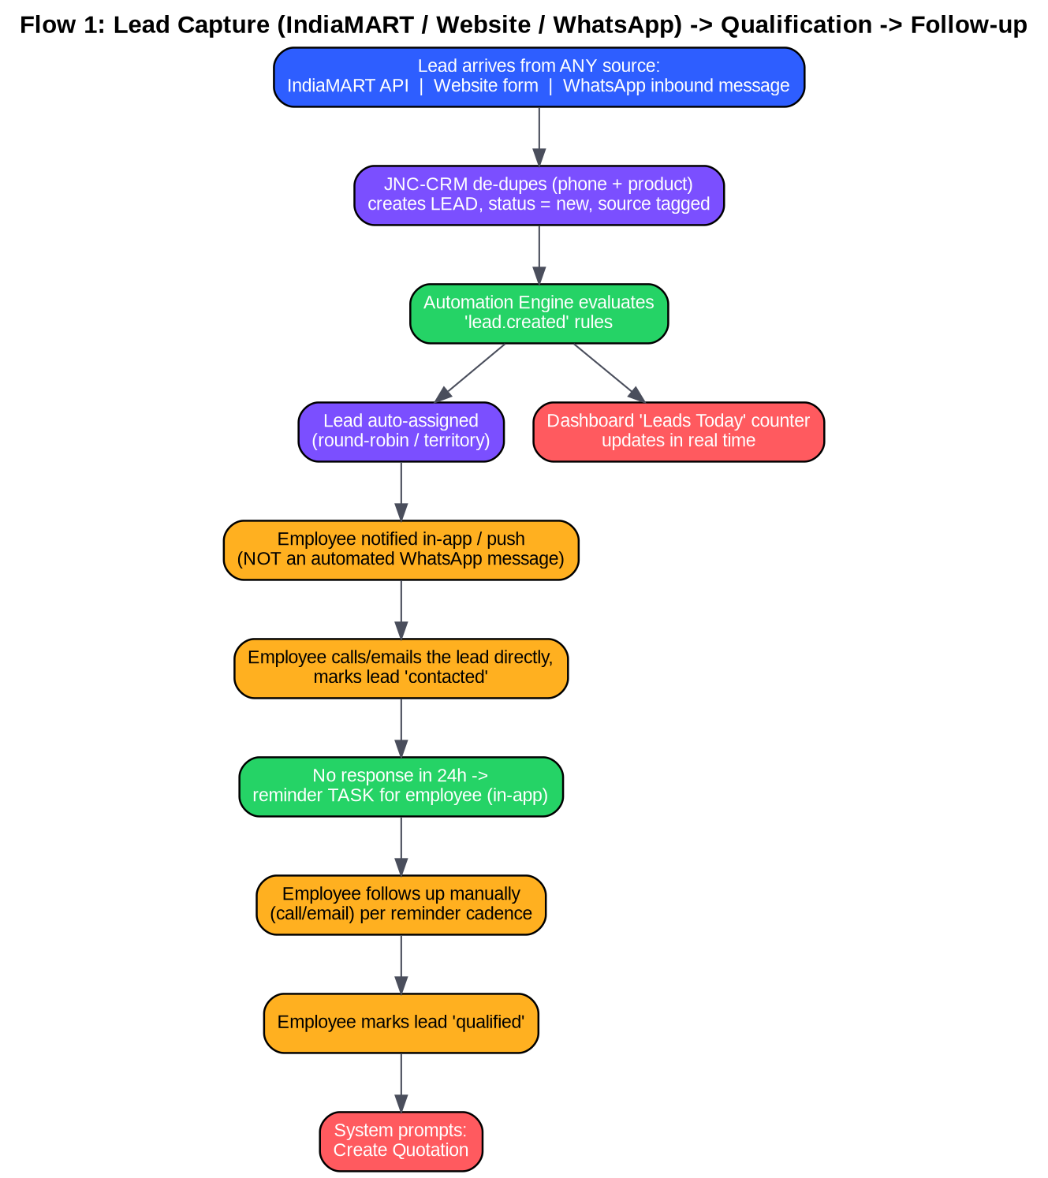
Figure 3 — All three sources (IndiaMART, Website, WhatsApp inbound) feed one lead pipeline. Follow-up is a task reminder for the employee, not an automated WhatsApp send.

4.2 Quotation → Order → Dispatch → Delivery

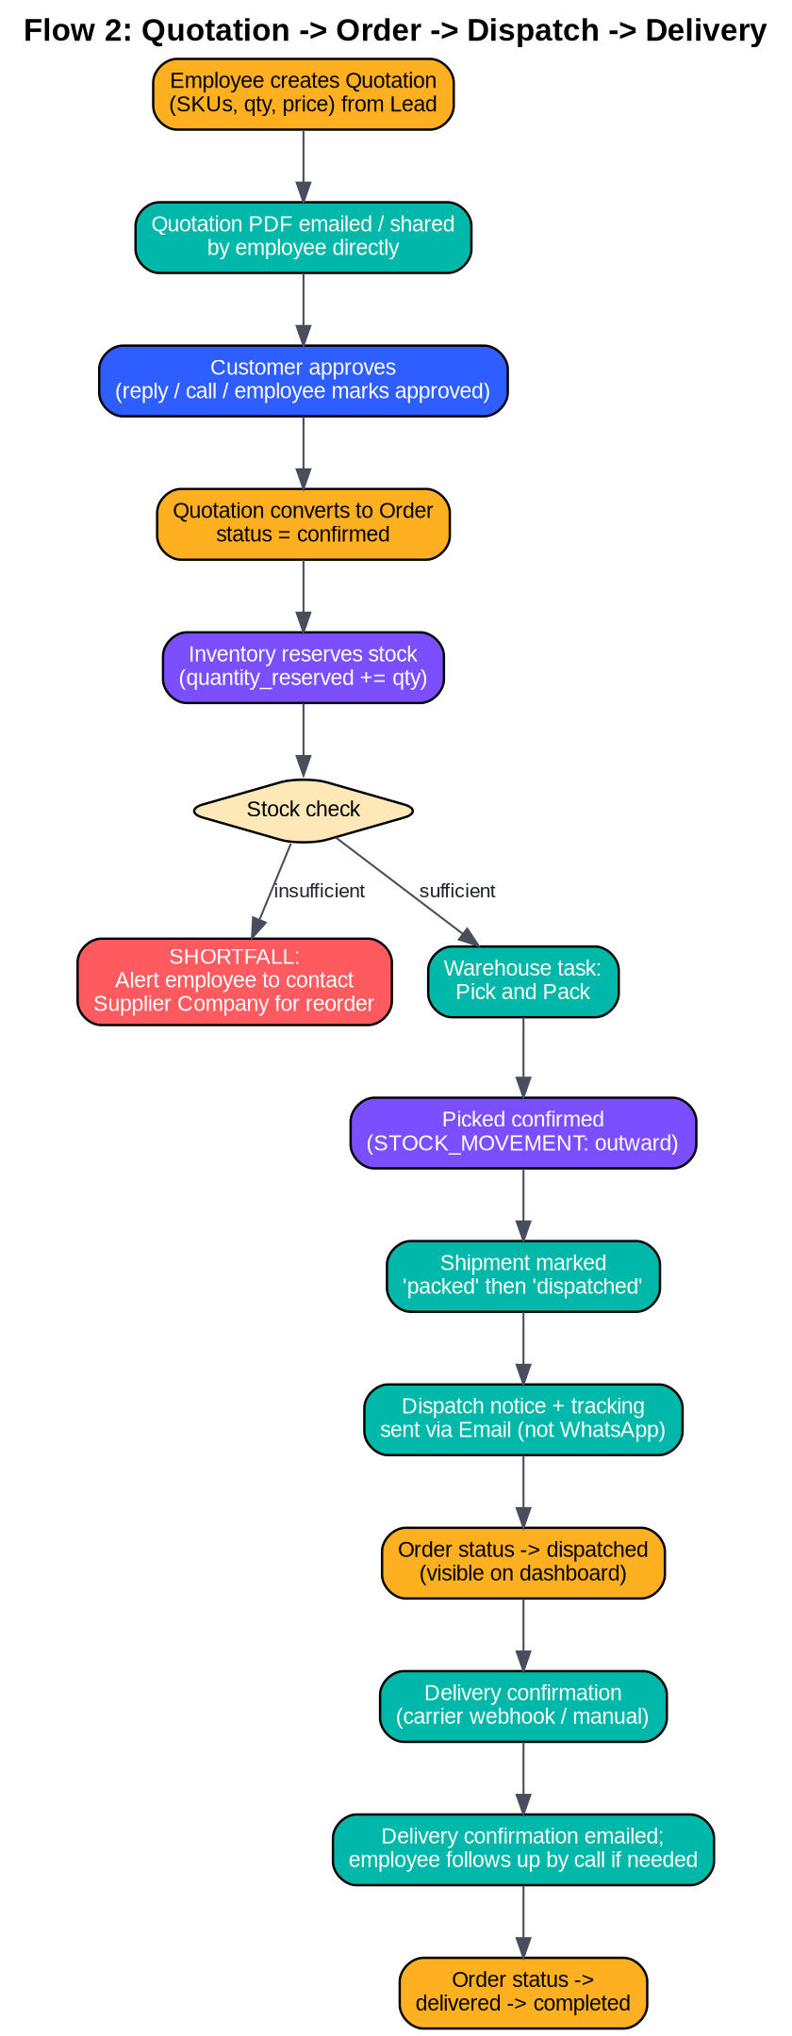
Figure 4 — Order lifecycle from quotation approval through delivery confirmation. Customer-facing updates go by email/call; WhatsApp is not used for outbound order communication.

4.3 Inventory Reorder Cycle

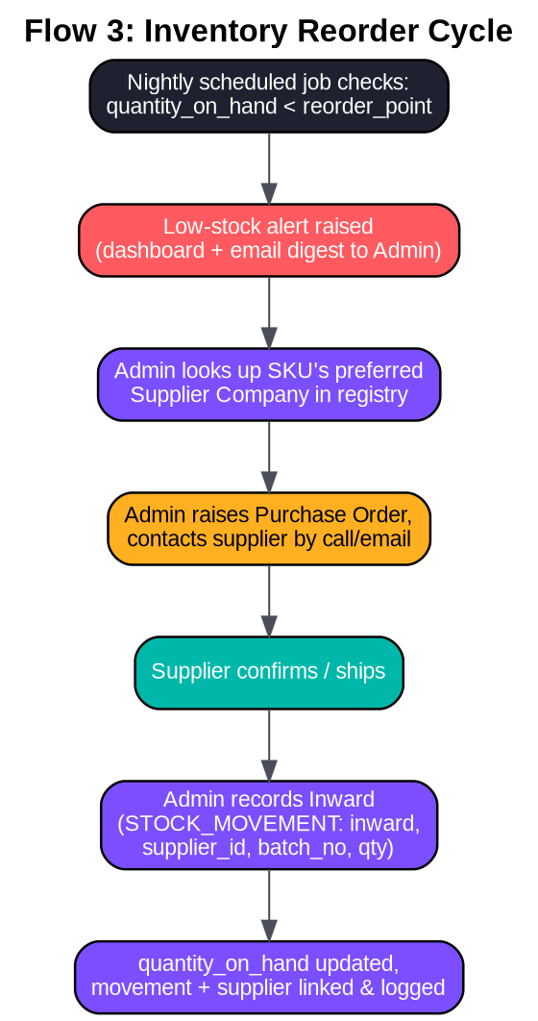
Figure 5 — Nightly reorder-point check, supplier lookup in the Supplier Company registry, and inward stock recording with supplier linkage.

5. Roles & Permissions (RBAC)
Capability | Super-Admin (Boss) | Admin | Sub-Admin | Employee
Create/deactivate users, assign IDs | Yes | Yes (own team only) | No | No
Reset credentials | Yes (anyone) | Yes (own team) | No | Yes (self only)
View all leads (org-wide) | Yes | Yes | Partial (assigned region/team) | Partial (assigned only)
Edit/reassign any lead | Yes | Yes | Partial (own team's) | No (own only)
Delete records (soft-delete) | Yes | Yes | No | No
Configure automation rules/templates | Yes | Yes | Partial (view only) | No
Approve quotations above threshold | Yes | Yes | Partial (below threshold) | No
Warehouse stock adjustments | Yes | Yes | Yes (own warehouse) | No (view only)
View financial/cost data (cost, margins) | Yes | Yes | No | No
View reports (org-wide) | Yes | Yes | Partial (team-scoped) | Partial (self-scoped)
Export data (CSV) | Yes | Yes | Partial (limited) | No
Audit log access | Yes | Partial (own team's actions) | No | No

Implementation pattern: permissions stored as role → permission[] plus row-level scoping via assigned_to / warehouse_id / team_id filters injected at the query layer (not just UI hiding). Every API endpoint checks both role permission and row-level scope server-side — never trust client-side hiding alone.
Credential/ID assignment flow: Admin creates user → system generates employee_code (e.g. JNC-EMP-0042) + temp password → forced password reset on first login → optional 2FA via Email or SMS OTP (not WhatsApp, kept consistent with no-outbound-WhatsApp policy).

6. Integrations

6.1 IndiaMART, Website & WhatsApp — all inbound lead sources into one CRM
All three channels connect into JNC-CRM as lead sources feeding the same LEAD table. No channel sends anything automatically back out to the customer — every outbound touch (call, email, WhatsApp reply) is done by an employee directly, using their own phone/WhatsApp/email, not a CRM bot.
- IndiaMART: use their CRM/Lead Manager API (push-based webhook if available on your plan, else scheduled pull every 5–10 min via their Lead API with START_TIME/END_TIME params). Map SENDER_NAME, SENDER_MOBILE, SENDER_EMAIL, SUBJECT, QUERY_MESSAGE, SENDER_CITY, PRODUCT → LEAD entity, source=indiamart.
- Website: contact/inquiry forms post directly to the CRM API, source=web.
- WhatsApp: connected via a BSP purely to receive inbound messages/inquiries and turn them into leads (source=whatsapp) — the CRM does not use WhatsApp to send anything automatically. An employee can still reply manually from their own WhatsApp app; that reply is outside the CRM's automation.
- De-duplication key across all three sources: normalized phone number + product category within a rolling 30-day window (configurable) — flagged as "repeat inquiry" on the existing lead instead of creating a new one.

6.2 Why no outbound WhatsApp automation
This is a deliberate design choice per your instruction: WhatsApp is for capturing inbound interest only. Automated follow-ups, quotations, dispatch notices, delivery confirmations, and payment reminders are handled by employees directly (call/email) or via automated Email/SMS — never an automated WhatsApp send. This also avoids Meta's strict template-approval and messaging-window rules entirely, since the CRM performs no outbound WhatsApp messaging.

6.3 Email & Telephony
- Transactional email (quotation PDFs, invoices, dispatch/delivery notices, low-stock digests) via SMTP relay or SendGrid/Amazon SES — this replaces WhatsApp as the automated outbound channel.
- Optional VoIP/telephony (Exotel, Knowlarity, or similar India-based click-to-call providers) — logs call attempts as LEAD_ACTIVITY with recording link, click-to-call button from the lead card.

6.4 CSV Import
- Generic importer with column-mapping UI, validation preview before commit, and de-dupe check against existing contacts/leads by phone/email.

7. API Specification (Representative Endpoints)
Base: /api/v1 · Auth: JWT bearer + refresh token · All list endpoints support ?page&limit&sort&filter[field]=value.
Method | Endpoint | Purpose | Role Gate
POST | /auth/login | Login (employee_code/email + password) | Public
POST | /auth/reset-password | Self-service reset (OTP via Email/SMS) | Authenticated
POST | /users | Create user + auto-generate ID | Admin+
PATCH | /users/{id}/deactivate | Deactivate user | Admin+
GET | /leads | List leads (filterable by status/source/assignee) | Scoped
POST | /leads | Manual lead creation | Employee+
POST | /webhooks/indiamart | Inbound IndiaMART lead push | System (signed)
PATCH | /leads/{id}/status | Update lead status | Scoped
POST | /leads/{id}/activities | Log call/note/meeting | Scoped
POST | /leads/import | CSV import | Sub-admin+
POST | /quotations | Create quotation from lead | Employee+
POST | /quotations/{id}/convert-to-order | Convert on approval | Employee+
GET | /orders | List orders (status filter) | Scoped
PATCH | /orders/{id}/status | Update order lifecycle status | Scoped
GET | /inventory/stock | Stock levels by SKU/warehouse | Scoped
POST | /inventory/movements | Record inward/outward/adjustment | Sub-admin+
POST | /inventory/transfers | Warehouse-to-warehouse transfer | Sub-admin+
GET | /inventory/reorder-alerts | SKUs below reorder point | Admin+
POST | /shipments | Create shipment for order | Sub-admin+
PATCH | /shipments/{id}/status | Update dispatch/delivery status | Sub-admin+
POST | /webhooks/whatsapp | Inbound WhatsApp message/status | System (signed)
POST | /automation-rules | Create/edit rule | Admin+
GET | /reports/lead-conversion | Funnel metrics | Scoped
GET | /reports/stock-aging | Aging inventory report | Admin+
GET | /audit-logs | Audit trail | Super-admin/Admin

Pattern notes: idempotency keys on all POST writes triggered by webhooks (IndiaMART/WhatsApp can redeliver); optimistic locking (version column) on ORDER/STOCK_ITEM to prevent race conditions on concurrent stock reservation.

8. Inventory & Warehouse Management
- Warehouse → Bin/Location hierarchy: Warehouse (e.g. "Bengaluru Main") → Zone → Rack → Bin (e.g. BLR-A-03-B12), so any SKU can be located physically in seconds — important for small electronic components where visual search is impractical.
- Supplier Company registry: every supplier you buy components from is a record (name, contact, lead time, preferred SKUs). The warehouse dashboard shows a live "Active Suppliers" count, and each SKU can show which supplier(s) it's sourced from and their price/lead-time history — useful when deciding who to reorder from.
- Reorder logic: per-SKU reorder_point and reorder_qty, computed alerts run nightly; the alert links directly to the SKU's preferred Supplier Company record so the admin doesn't have to search for who to call. Optionally auto-generate a draft Purchase Order for admin approval rather than fully automated purchasing.
- Batch/Lot & date-code tracking: every inward movement recorded against a batch_no and the supplier it came from; outward movements default to FIFO by batch, overridable manually — critical for components with limited shelf life or where customers require date-code traceability for RMA.
- Stock reservation: confirming an order reserves stock (quantity_reserved) without decrementing quantity_on_hand until actual pick/pack — prevents overselling while keeping visibility of "available to promise" = on_hand - reserved.
- Transfer workflow: inter-warehouse transfer creates paired STOCK_MOVEMENT records (outward at source, inward at destination) with an in-transit intermediate state.
- Cycle counts: scheduled/manual stock-count sessions that reconcile system quantity vs physical count, logging variance as an adjustment movement with mandatory reason code.

9. UI/UX & Visual Design System

9.1 Design Direction
A vibrant, high-contrast, motion-forward dashboard suited to a fast-moving sales+ops floor — confident color-blocking per module (not muted enterprise gray), large legible numbers, and micro-animations that make status changes feel alive without being distracting.

9.2 Color System (module-coded)
Module | Primary | Accent | Use
Leads / Pipeline | Electric Blue #2E5EFF | Sky #8FB8FF | Lead cards, funnel stages
WhatsApp Leads | WhatsApp Green #25D366 | Mint #B9F5D0 | Inbound lead badges only — no outbound message UI
Orders / Quotations | Amber #FFB020 | Cream #FFE8B8 | Order stage chips, quote status
Inventory / Warehouse | Violet #7B4FFF | Lilac #DCCBFF | Stock cards, bin maps
Shipments / Dispatch | Teal #00B8A9 | Aqua #B8F2ED | Tracking timelines
Alerts / Reorder | Coral Red #FF5A5F | Blush #FFD8D9 | Low-stock, overdue follow-ups
Neutral base | Charcoal #1E2230 | Off-white #F7F8FC | Backgrounds, text

Dark-mode variant mirrors the same hues at reduced saturation on a #12141C base for factory/warehouse low-light use.

9.3 Animation & Motion Principles
- Status transitions animate physically: a lead card sliding from "New" → "Contacted" uses a spring-eased slide+fade, not an abrupt re-render.
- Live counters (today's leads, pending dispatches) count up/down with number-tween animation on change, not a static re-paint.
- New-lead arrival: a small animated badge/pulse on the Leads Today counter and the relevant source icon (IndiaMART / Website / WhatsApp) when a new lead lands, so the team feels the pipeline is alive without any outbound message being sent.
- Stock level bars: animated fill bars (green→amber→red gradient tied to reorder threshold) that visibly deplete as orders reserve stock.
- Skeleton loaders, not blank spinners, for all data fetches — shimmering placeholder cards matching final layout shape.
- Toasts/notifications slide in from top-right with color-coded left border matching module color; auto-dismiss with a shrinking progress bar.
- Motion budget: keep transitions 150–300ms, respect prefers-reduced-motion for accessibility.

9.4 Key Screens (wireframe structure)
- Boss/Admin Dashboard — the top-left KPI tile is always "Leads Today" (large animated counter, split by source: IndiaMART / Website / WhatsApp / Manual), alongside Pending Follow-ups, Orders in Transit, Low Stock SKUs, and Active Supplier Companies.
- Lead Pipeline (Kanban) — New → Contacted → Qualified → Quoted → Won/Lost columns, drag-and-drop cards color-coded by source (IndiaMART orange, Website blue, WhatsApp green, Manual gray), inline quick-actions (call, email, note) — no automated-send button, since outreach is manual by design.
- Lead/Contact Detail — activity timeline (calls, emails, notes) + quotation history, persistent "Next Action" sticky card showing the reminder task, not an auto-sent message log.
- Inventory Dashboard — warehouse selector tabs, SKU table with animated stock bars, bin-location heatmap, reorder alert rail that links straight to the relevant Supplier Company.
- Supplier Companies screen (new) — a searchable list/table of every supplier: name, contact, SKUs supplied, last order date, lead time. A prominent counter shows total active suppliers, matching the dashboard tile.
- Order/Shipment Tracker — horizontal animated stepper (Confirmed → Processing → Dispatched → Delivered), customer-facing status visible to the assigned employee to relay by call/email.
- Automation Builder — visual trigger→condition→action rule builder; action options are limited to Email / SMS / In-app task — no WhatsApp-send option is exposed, by design.
- Mobile (PWA/React Native) — bottom tab nav (Leads / Orders / Inventory / Suppliers / More), swipe-to-call, push notifications for new leads and low-stock alerts, responsive down to 360px width.

10. Automation Rule Library (starter set)
Revised per your instruction: none of these rules send an automated WhatsApp message. WhatsApp only creates leads (rule 2 covers a WhatsApp-sourced lead the same as any other). All outbound automation uses email, in-app notifications, or internal tasks for an employee to action personally.
# | Trigger | Condition | Action
1 | Lead created (any source) | any | Auto-assign round-robin within active sales team; update "Leads Today" counter
2 | Lead created | source = IndiaMART / Website / WhatsApp | In-app / push notification to assigned employee (no auto WhatsApp/SMS to customer)
3 | Lead status = new | no activity in 24h | Create reminder TASK for employee (in-app) — employee calls/emails manually
4 | Lead status = contacted | no activity in 72h | Escalation task to Admin/Sub-admin for visibility
5 | Lead status = contacted | no activity in 7 days | Auto-tag lead "cold"; remove from active follow-up queue
6 | Quotation sent | no response in 3 days | Reminder task for employee to call/email the customer
7 | Order status → confirmed | any | Reserve stock; notify warehouse team (in-app)
8 | Order status → dispatched | any | Automated Email with tracking info (not WhatsApp); dashboard status updates
9 | Order status → delivered | any | Automated Email confirmation + optional feedback link
10 | quantity_on_hand < reorder_point | any | Admin dashboard alert + daily email digest, linked to preferred Supplier Company
11 | Lead marked "lost" | reason = price | Add to 90-day win-back list (employee follow-up, not automated send)
12 | Payment overdue | pending > X days | Email payment reminder + admin alert task
13 | New user created by Admin | any | Temp credentials shown to Admin to hand over; forced reset on first login

Rules stored as trigger_event + condition_json + action_type, editable via the Automation Builder UI — no code deploy needed to add/adjust a rule.

11. Reporting & KPIs
KPI | Formula / Definition | Refresh
Leads Today | Count of LEAD records created today, by source (IndiaMART / Website / WhatsApp / Manual) | Real-time
Lead-to-Order Conversion Rate | Orders won / Total leads (by period, source, employee) | Real-time
Avg. First Response Time | Time from lead.captured_at → first LEAD_ACTIVITY | Real-time
Lead Source Mix | % of leads from each source over time — tracks channel effectiveness | Daily
Stock Aging | Days since last movement per batch, bucketed (0-30/31-60/61-90/90+) | Daily
Reorder Compliance | % of reorder alerts actioned within SLA (e.g. 48h) | Daily
Active Supplier Companies | Count of suppliers with at least one inward movement in last 90 days | Daily
Shipping Accuracy | Orders delivered without return/complaint / total delivered | Weekly
On-Time Dispatch Rate | Dispatches within SLA of order confirmation | Daily
Sales by Employee/Territory | Order value grouped by assignee/region | Real-time
Win/Loss Reason Breakdown | Count of lost_reason categories | Weekly

Dashboards should support date-range compare (this month vs last) and CSV export for board-level reporting.

12. Security, Compliance, Backups & Monitoring
- India data protection (DPDP Act, 2023): treat customer phone/email/company data as personal data — capture consent at lead source where feasible, honor opt-out/erasure requests, maintain a data-processing log, and define a retention policy per entity.
- Access security: bcrypt/argon2 password hashing, JWT short-lived access tokens + refresh tokens, optional Email/SMS-OTP 2FA for admin roles, IP-restriction option for admin panel if needed.
- Encryption: TLS 1.2+ everywhere in transit; at-rest encryption on the database volume and object storage.
- Backups: automated daily full DB backup + continuous point-in-time recovery (Postgres), 30-day retention minimum, backups stored in a separate region/bucket, monthly restore-drill to verify integrity.
- Audit logging: every create/update/delete/status-change/login/permission-change recorded in AUDIT_LOG (actor, action, entity, before/after diff, IP, timestamp) — immutable, admin-readable only.
- Monitoring/SLA: uptime monitoring, error tracking (Sentry), structured logs; suggested SLA: 99.5% uptime business hours, WhatsApp webhook processing < 5s, page load < 2s on 4G.
- Rate limiting & webhook signature verification on all inbound integration endpoints (IndiaMART, WhatsApp) to prevent spoofed payloads.

13. Technology Stack Recommendation
Layer | Recommendation | Why
Frontend (Web) | React + TypeScript, Tailwind CSS, Framer Motion, Recharts/Chart.js | Fast to build vibrant animated UI; matches the color/motion system
Mobile | React Native (or PWA first, native later) | Code-sharing with web team, push notifications, offline-friendly
Backend | Node.js (NestJS) or Python (FastAPI/Django) | Pair well with async webhook-heavy integration work
Database | PostgreSQL (primary), Redis (queues/cache/session) | Relational integrity for inventory/orders; JSONB for raw payloads
Queue/Jobs | BullMQ (Node) or Celery (Python) on Redis | Automation engine, scheduled reorder checks, sequence timers
File/Object storage | S3-compatible (AWS S3 / Backblaze B2 / DO Spaces) | Quotation PDFs, product images, attachments
WhatsApp | BSP or direct Meta Cloud API webhook — receive-only, no template messaging needed | Simpler setup since no outbound template approval is required; only inbound lead capture
Hosting | AWS ap-south-1 (Mumbai) or equivalent India-region cloud | Data locality/latency and compliance comfort
CI/CD | GitHub Actions → Docker → managed hosting (ECS/Fly.io/Render) | Simple, low-ops for a small team
Search (phase 2+) | Postgres full-text initially; Meilisearch/Elasticsearch later | Avoid overhead until catalog scale demands it

API pattern: REST + JSON for the core CRM API; webhooks for inbound IndiaMART/WhatsApp events; GraphQL only if the frontend team later wants flexible nested queries — not needed at launch.

14. Testing Strategy
Layer | Approach
Unit tests | Core business logic — stock reservation math, automation rule evaluation, lead de-dupe logic. Target 70%+ coverage on services.
Integration tests | API endpoints against a test DB; webhook payload handling with recorded fixture payloads.
E2E tests | Playwright/Cypress covering lead → quotation → order → dispatch happy path; RBAC boundary tests.
Load testing | k6/Locust on webhook ingestion and dashboard queries at target concurrency (30–50 users).
UAT | Structured UAT script with the actual sales/warehouse team before each phase go-live.
Security testing | Basic OWASP Top 10 pass before go-live; annual re-check as it grows.

15. Phased Implementation Plan
Total: approximately 20 weeks (5 months) to full feature set, structured as 2-week sprints, front-loading the highest-value modules (unified lead capture + automation + inventory basics) so the team gets value within 6–8 weeks.
Phase | Sprints | Weeks | Scope
Phase 0 — Foundation | Sprint 0 | Wk 1–2 | Requirements sign-off, data model finalization, environment setup, auth/RBAC skeleton, design system build, CI/CD pipeline
Phase 1 — Lead Core | Sprint 1–2 | Wk 3–6 | Lead CRUD, IndiaMART integration, manual entry, CSV import, lead Kanban UI, contact/company model, basic dashboard
Phase 2 — Unified Lead Capture & Automation | Sprint 3–4 | Wk 7–10 | WhatsApp inbound webhook (lead capture only), automation rule engine (triggers 1–7 from Section 10), in-app task/reminder engine, email notification templates
Phase 3 — Orders & Inventory | Sprint 5–7 | Wk 11–16 | Quotation builder, order lifecycle, product/SKU catalog, warehouse/bin model, stock movements, reorder alerts, batch tracking, shipment tracking
Phase 4 — Reporting & Polish | Sprint 8–9 | Wk 17–19 | Full KPI dashboards, exportable reports, animation polish pass, mobile app/PWA hardening, audit log UI, performance tuning
Phase 5 — UAT, Hardening, Go-Live | Sprint 10 | Wk 20 | Security pass, load testing, backup/DR drill, user training, phased rollout

Post-launch (Phase 6, ongoing): telephony/VoIP integration, advanced sales forecasting, win-back campaign automation, multi-warehouse transfer optimization, native mobile app (if PWA proves insufficient).

16. Resource & Cost Estimates (India-based delivery)

16.1 Team Composition (for the 20-week build)
Role | Allocation | Notes
Tech Lead / Architect | Full-time | Owns architecture, code review, integration design
Backend Developer x2 | Full-time | API, automation engine, integrations, inventory logic
Frontend Developer x2 | Full-time | React web app, animation system, dashboards
Mobile/PWA Developer | Full-time from Phase 3 | Mobile responsiveness & app
UI/UX Designer | Full-time Phase 0–1, part-time after | Design system, wireframes, animation spec
QA Engineer | Part-time ramping to full-time Phase 4–5 | Test plans, E2E automation
DevOps (shared) | ~0.25 FTE throughout | CI/CD, hosting, monitoring, backups
Project Manager | Part-time | Sprint planning, client coordination

16.2 Indicative Cost Bands (India market rates, INR)
Item | Low Estimate | High Estimate
Development team (20 weeks, blended) | Rs 22,00,000 | Rs 45,00,000
UI/UX design system & wireframes | Rs 2,00,000 | Rs 5,00,000
WhatsApp BSP subscription (monthly, receive-only) | Rs 1,500–4,000/mo | Rs 6,000–15,000/mo
Cloud hosting (India region, monthly) | Rs 8,000/mo | Rs 35,000/mo
Domain/SSL/misc SaaS (monitoring, email) | Rs 3,000/mo | Rs 10,000/mo
QA / security testing pass | Rs 1,50,000 | Rs 4,00,000
Total build (one-time) | ~Rs 25–30 lakh | ~Rs 55–60 lakh
Ongoing run cost (monthly, post-launch) | ~Rs 15,000–20,000 | ~Rs 90,000–1,10,000

These are directional planning ranges for budgeting conversations, not vendor quotes — actual numbers depend heavily on in-house vs agency delivery and final integration/message volumes. Treat this as a starting point to RFQ against.

16.3 Cost-saving levers if budget is tighter
- Start with Phase 0–2 only (Foundation + Leads + WhatsApp) as an MVP — typically the biggest ROI for roughly 40% of total budget.
- Use a low-code inventory module initially (e.g. a structured Airtable/NocoDB layer behind the same API contract) and migrate to custom-built inventory in Phase 3.
- Defer native mobile app; PWA covers most "on-the-go" needs at a fraction of the cost.

17. Risks & Mitigations
Risk | Mitigation
WhatsApp BSP inbound webhook setup delays (Meta business verification) | Start Meta Business verification in Sprint 0; since no outbound templates are needed, approval is faster than a full messaging setup
IndiaMART API rate limits / plan restrictions | Confirm API tier with account manager before Sprint 1; build pull-based fallback with backoff
Inventory data migration from spreadsheets is messy | Dedicate explicit CSV-cleanup sprint time in Phase 3; validate with a warehouse staff walkthrough before cutover
Team resists new system vs. familiar WhatsApp+Excel habits | Pilot with 1–2 employees first (Phase 5), gather feedback, make automation visibly reduce manual work early
Scope creep on "fully animated" UI delaying core delivery | Design tokens locked in Phase 0; animation applied incrementally, never blocking a functional release

Next Steps
- Confirm/adjust the assumptions on page 3 (team size, warehouse count, budget band, WhatsApp BSP preference).
- Confirm IndiaMART API tier and current WhatsApp Business API status.
- Approve the phased plan and starting team composition, or scope down to an MVP (Phase 0–2) per Section 16.3.
- Any single section — RBAC matrix, sprint backlog, automation rule set — can be turned into its own working spreadsheet or deck for stakeholder review.

